DANUTE MARDOSIENE

Chair of Baltic Division of UNGEGN

Deputy chief of GIS and Mapping Division

National Land Service under the Ministry of Agriculture

of the Republic of Lithuania

UNITED NATIONS EXPERTS GROUP

OF GEOGRAPHICAL NAMES

(UNGEGN )

STRUCTURE AND ACTIVITIES

8th workshop of Baltic Division of ungegn

6-8 September 2004

Vilnius

UNITED NATIONS EXPERTS GROUP

OF GEOGRAPHICAL NAMES

(UNGEGN )
STRUCTURE

1. UNGEGN SECRETORIAT

↓

2. UNGEGN BUREAU

↓

3 WORKING GROUPS (9)

Exemplar: Romanisation Systems WG

↓

4. DIVISIONS ( 22 )

Exemplar: Baltic Division

(Estonia, Latvia, Lithuania)

↓

5. National Names AUTHORITIES of STATES

Exemplar: Valstybinė lietuvių kalbos komisija

State Commission of Lithuanian Language

↓

6. National mapping AUTHORITIES OF STATES

Exemplar: Valstybinė Žemės tarnyba

National Land Service

UNGEGN SECRETORIAT at UN Headquarters in New York
Mr. Amor Laaribi
United Nations Statistics Division, Office of the Director
Two UN Plaza DC2-1640
New York, NY 10017
Tel: (212) 963-3042
Fax: (212) 963-9851
E-mail: laaribi@un.org
and
Ms Jennifer C. Javier
United Nations Statistics Division
Two UN Plaza DC2-1641A
New York, NY 10017
Tel: (212) 963-5951
Fax: (212) 963-9851
E-mail: javier@un.org

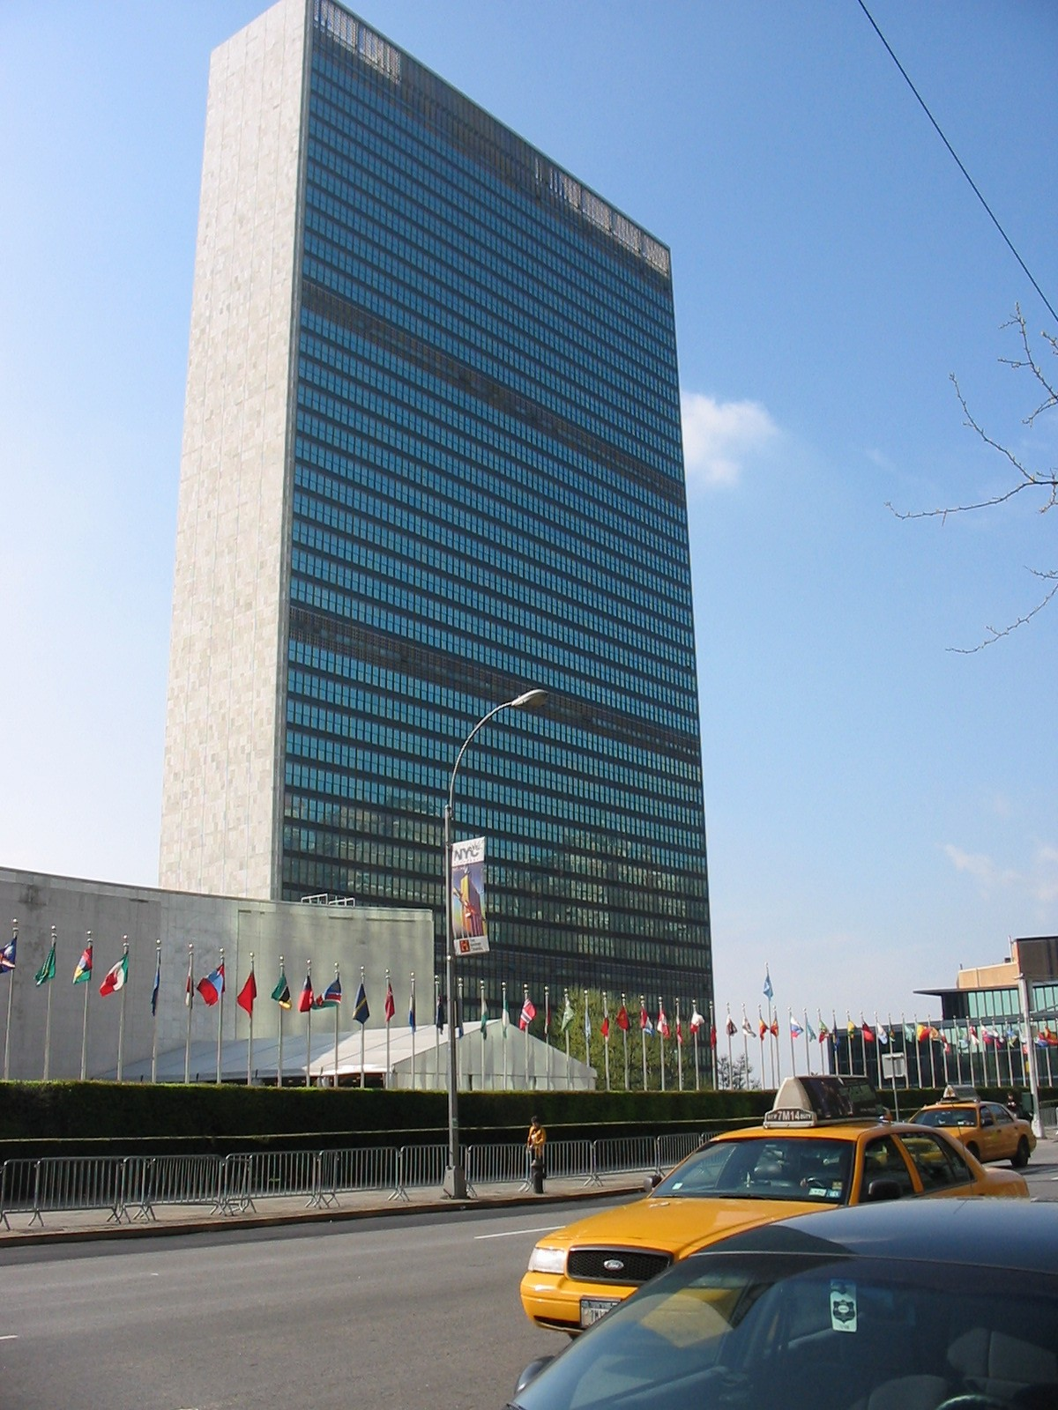

UNGEGN BUREAU, 2002-2007

Chairperson
Ms Helen Kerfoot, Canada
E-mail: hkerfoot@NRCan.gc.ca

Vice-Chairpersons
- Mr. Brahim Atoui, Algeria
E-mail: inct99@wassal.dz
- Mr. Joern Sievers, Germany
E-mail: sievers@ifag.de

Rapporteurs
- Mr. Brian Goodchild, Australia
E-mail: Brian_Goodchild@dola.wa.gov.au
- Mr. Donall Mac Giolla Easpaig, Ireland
E-mail: dmacgiollaeaspaig@pobail.ie

UNGEGN WORKING GROUPS AND

CONVENORS 2002 -2007

1.Romanization Systems
Mr. Peeter Päll, Estonia
E-mail: peeter@eki.ee
2. Training Courses in Toponymy
Mr. Ferjan Ormeling, Netherlands
E-mail: Ormeling@geog.uu.nl
3. Toponymic Terminology
Mr. Naftali Kadmon, Israel
E-mail: msnkadmo@mscc.huji.ac.il
4. Country Names
Ms Sylvie Lejeune, France
E-mail: Sylvie.Lejeune@ign.fr
5. Publicity and Funding
Mr. David Munro, United Kingdom
E-mail: David.Munro@strath.ac.uk
6. Toponymic Data Files and Gazetteers
Mr. Randall Flynn, USA
E-mail: flynnre@nima.mil
7. Evaluation and implementation
Mr. Ki-Suk Lee, Republic of Korea
E-mail: leekisuk@plaza.snu.ac.kr
8. Exonyms
Mr. Milan Orozen Adamic, Slovenia
E-mail: milan@zrc-sazu.si

9. Pronunciation

Mr. Donall Mac Giolla Easpaig, Ireland
E-mail: dmacgiollaeaspaig@pobail.ie

UNGEGN WORKING GROUPS in details
Under the umbrella of UNGEGN, several working groups have been created to follow up topics and issues which cut across the Divisional structure of UNGEGN. In the short outlines that follow, the convenor of each working group is indicated and can be contacted for more details.
1. Working Group on Country Names
Convenor: Leo Dillon (USA) ACLDillo@us-state.osis.gov
The most recent list of recommended country names was issued as E/CONF.94/CRP.11 at the Eighth United Nations Conference on the Standardization of Geographical Names in 2002. (The previous version was available as E/CONF.91/L.65 and Add.1 from the Seventh Conference in 1998, with updates in WP 33 of the 20th Session of UNGEGN, 2000).
The Working Group met in London (UK), May 14-15, 2001 to prepare the revised document for distribution at the Eighth Conference.
Ongoing work programme:
- continue updating and completing local official forms;
- expand the list to other official languages of the United Nations;
- compare existing lists of country names to identify differences and, where possible, to eliminate them.
Reports of the Working Group on Country Names can be found in UNGEGN Newsletter 23, July 2000 and as WP 1 of the 21st Session of UNGEGN, 2002 (in French)
Suggested web sites:
- List of country names and associated practical information on the web site of the Cartography Section, United Nations, New York
http://www.un.org/Depts/Cartographic/english/geoinfo/geoname.pdf

2. Working Group on Gazetteers and Toponymic Data Files
Convenor: Randall Flynn (USA) flynnre@nima.mil
This Working Group now addresses various issues of toponymic data processing, including the creation, maintenance and outputs of toponymic data files (including gazetteer production) and aspects of toponymic data exchange formats and standards (including encoding of characters found in geographical names).
The Working Group met in Ljubljana, Slovenia, on 19 April 2001 and during the 8th UNCSGN in 2002.
Current work plan:
- maintain and revise the Report of the Working Group on Toponymic Data Exchange formats and Standards to the Seventh United Nations Conference on the Standardization of Geographical Names (presented in 1998 as E/CONF.91/CRP.11)
- maintain liaison with the Unicode Consortium regarding digital text encoding in the context of geographical names and with the International Organization for Standardization (ISO) with reference to development of exchange standards for toponymic information
- promote implementation of practical programs and toponymic data exchange
- promote and conduct toponymic data exchange workshops
Reports of the Working Group on Gazetteers and Toponymic Data Files can be found in E/CONF.94/INF.12 (Eighth Conference, 2002), in WP 6 of the 21st UNGEGN Session (2002), WP 46 of the 20th UNGEGN Session (2000) and in the UNGEGN Newsletter 23, July 2000.
Web sites:
- The Working Group web site can be accessed at http://www.zrc-sazu.si/ungegn/
- software and fonts
ISO/IEC 10646-1 ... information on relevant Unicode Consortium publication
http://www.unicode.org/unicode/uni2book/u2.html
Information about Unicode-enabled products:
http://www.unicode.org/unicode/standard/UnicodeEnabledProducts.html

3. Working Group on Toponymic Terminology
Convenor: Naftali Kadmon (Israel) msnkadmo@mscc.huji.ac.il
The main task of the Working Group since its inception in 1991 has been to develop a revised Glossary of Toponymic Terminology. This has now been completed and the text published by the United Nations. The Glossary consists of six language versions combined in one volume with appropriate cross-referencing.
The Glossary of Terms for the Standardization of Geographical Names was published in 2002 and can be purchased as a United Nations Publication (Sales No. M.01.XVII.7).
The text can be accessed as a .pdf document on the UNGEGN website (http://unstats.un.org/unsd/geoinfo/glossary.pdf)
The Working Group met during the Eighth Conference and on a continuing basis will now review the terms for updates, additions, etc.
Recent reports of the Working Group on Toponymic Terminology will be found in E/CONF.94/CRP.86 of the Eighth Conference, in WP 4 of the 21st Session of UNGEGN, and in UNGEGN Newsletter 23, July 2000.

4. Working Group on Publicity and Funding
Convenor: David Munro (United Kingdom) David.Munro@strath.ac.uk
This Working Group was set up following the Sixth UN Conference on the Standardization of Geographical Names in 1992. Its aims are to make the activities of UNGEGN more visible and, where appropriate, to seek funds to support the production and relevant publications and promotional material.
The brochure "Consistent Use of Place Names", based on text prepared by UNGEGN, was published in English in Australia (1999) and presented to the 20th session of UNGEGN in 2000. Subsequently, the brochure has been published by the United Nations in six languages (Arabic, Chinese, English, French, Russian and Spanish) and is available for downloading as a .pdf file at: http://unstats.un.org/unsd/geoinfo/ungegnbrochure.htm.
The text of the brochure may be translated, and the brochure may be reproduced in other languages (but should include a disclaimer stating that the UN is not responsible for the translation...please contact Mr. Amor Laaribi at Laaribi@un.org).
Current tasks of the Working Group:
- Priority will be given to the production of two UNGEGN publications, namely a basic manual on geographical names and a more technical document, including such material as Romanization systems, formats and standards for toponymic data exchange, and country names in the language(s) of the country.
- Ensuring the maintenance and further development of the UNGEGN web site (http://unstats.un.org/unsd/geoinfo/) and the continuation of the UNGEGN Newsletter to provide focal points for disseminating news, information, publications and a network of web links.
Reports of the Working Group on Publicity and Funding:
- WP 5 to the 21st UNGEGN, 2002
- in UNGEGN Newsletter 23, July 2000 and in UNGEGN Newsletter 24, July 2001.

5. Working Group on Romanization Systems
Convenor: Peeter Päll (Estonia) peeter@eki.ee
The basic mandate of the Working Group is to consider and reach agreement on a single romanization system for geographical names proposed by a (donor) country using a non-Roman writing system. The process requires time for full consultations on technical matters between the Working Group, the proposers and potential users. Romanization systems should be based on sound scientific principles and be implemented by the proposing country. New systems are referred to the United Nations Conferences on the Standardization of Geographical Names for resolution and vote before becoming a United Nations standard.
The Working Group met in London (UK), 16-17 May 2001 and during the Eighth United Nations Conference on the Standardization of Geographical Names (8th UNCSGN.)
The latest reports of the Working Group are:
- Report by the Convenor, UNGEGN 2002, W.P.3
- Report of the Working Group on Romanization Systems: activities from January 1998 to May 2002 (8th UNCSGN 2002), E/CONF.94/CRP.80
- United Nations Romanization Systems for Geographical Names- Report on their current status (8th UNCSGN 2002), E/CONF.94/CRP.81
Earlier reports of the Working Group on Romanization Systems in UNGEGN Newsletter 23, July 2000 and in UNGEGN Newsletter 24, July 2001.
Web site:
The Working Group has its own web site at http://www.eki.ee/wgrs/
- the web site contains updated versions of romanization systems (currently for 45 languages) as presented to the Conference and in working group documents;
- romanization systems are available for download as pdf files.

6. Working Group on Training Courses in Toponymy
Convenor: Ferjan Ormeling (Netherlands)toponymy@geog.uu.nl
The Working Group coordinates information on toponymy training courses, and where required assists in their planning. A course was recently offered in conjunction with the Eighth United Nations Conference on the Standardization of Geographical Names in Berlin (August 2002); details can be found in E/CONF.94/CRP.36.
The Working Group on Training Courses in Toponymy reported to the Eighth Conference (E/CONF.94/INF.51) and in UNGEGN Newsletter 23, July 2000.
Web site:
- The Working Group's web site is available at http://toponymycourses.geog.uu.nl/. It provides information on the Working Group, on forthcoming and past courses, and on teaching material used in toponymy courses and for other purposes

7. Working Group on Evaluation and implementation

Convenor: Ki-Suk Lee (Republic of Korea) leekisuk@plaza.snu.ac.kr
The original Working Group on Evaluation was established to address resolution 4 of the Fifth United Nations Conference in 1987. Reports of the Working Group were presented to UNGEGN at its 14th Session in 1989 (WP 31), at its Session in 1991 (WP 55), and its 16th Session in 1992 (WP3). The Working Group was then disbanded in favour of a new working group to consider the particularly important aspects of publicity and funding.
However, as the work of evaluation of UNGEGN and the Conferences needs to be considered on a continual basis, the Working Group was re-established during the 20th Session of UNGEGN (2000). Reports by members of this group were received at the 21st Session of UNGEGN in 2002 (WP 8, WP 9).
Current work plan:
The work plan is under development, but includes an evaluation of the functioning and efficacy of UNGEGN and the implementation of resolutions, finding ways to involve member states not currently participating in UNGEGN, and looking at the needs of developing countries to achieve national standardization of their geographical names.
8. Working Group on Exonyms

Convenor: Milan Orozen Adamic (Slovenia) milan@zrc-sazu.si
The Working Group was formed in September 2002, as recommended by resolution 4 of the Eighth Conference (Berlin, 27 August - 5 September 2002). The need for such a group had also been expressed at earlier discussions (Frankfurt am Main, 2000 and Berchtesgaden, 2001).
Current work plan:
Various conference resolutions now exist on the treatment, use and reduction of exonyms in the context of geographical names standardization and effective UN communication. The Working Group will be developing its work plan to encourage progress in addressing these UN resolutions. Those interested in participating in Working Group activities should contact the Convenor.
Meeting of the Working Group:
A meeting will be held in Praha (Prague), September 24-26, 2003, in conjunction with a meeting of the East Central and South-East Europe Division.
Web site:
The Working Group website, where discussion details and membership will be posted, is being developed.
9. Working Group on Pronunciation

Convenor: Donall Mac Giolla Easpaig (Ireland) dmacgiollaeaspaig@pobail.ie
The Working Group was formed in response to resolution 11 of the Eighth Conference (Berlin, 27 August - 5 September 2002), which noted that the transliteration of geographical names from the script of one language into another script, such as romanization, does not normally provide a guide to the correct pronunciation of such names by persons who are unacquainted with the source language.

DIVISIONS
- Africa Central Division
Angola, Burundi, Cameroon, Central African Republic, Chad, Congo, Democratic Republic of the Congo, Equatorial Guinea, Gabon, Rwanda, Sao Tome and Principe
(Chair: )
- Africa East Division
Botswana, Djibouti, Ethiopia, Kenya, Lesotho, Madagascar, Malawi, Mauritius, Mozambique, Seychelles, Sudan, Swaziland, Uganda, United Republic of Tanzania, Zambia, Zimbabwe
(Chair: Mr. Nasr Hassanein, Sudan) (Secretary: Mr. Alix Mwanza, Zambia)
- Africa South Division
Botswana, Lesotho, Malawi, Mozambique, Namibia, South Africa, Swaziland, Zambia, Zimbabwe
(Chair: Mr. Langalibalele Mathenjwa, South Africa) (Vice-Chair: Mr. Luis Abrahamo, Mozambique)
- Africa West Division
Benin, Burkina Faso, Cape Verde, Cōte d'Ivoire, Gambia, Ghana, Guinea, Guinea-Bissau, Liberia, Mali, Mauritania, Niger, Nigeria, Senegal, Sierra Leone, Togo
(Chair: Ms Felicia Akinyemi, Nigeria)(Secretary: Mr. Mohamed Hassimiou Fofana, Guinea)
- Arabic Division
Algeria, Egypt, Iraq, Jordan, Kuwait, Lebanon, Libyan Arab Jamahiriya, Morocco, Oman, Saudi Arabia, Sudan, Syria Arab Republic, Tunisia, United Arab Emirates, Yemen
(Chair: )
- Asia East Division (other than China)
Democratic People's Republic of Korea, Japan, Republic of Korea
(Acting Chair: Mr. Ki-Suk Lee, Republic of Korea)
- Asia South-East and Pacific South-West Division
Australia, Bhutan, Brunei Darussalam, Cambodia, Indonesia, Lao People's Democratic Republic, Malaysia, Myanmar, New Zealand, Nauru, Papua New Guinea, Philippines, Singapore, Thailand, United States, Vanuatu, Viet Nam
(Chair: Mr. Pg Hj Matusin bin Pg Hj Matasan, Brunei Darussalam)
- Asia South-West Division (other than Arabic)
Afghanistan, Azerbaijan, Cyprus, Islamic Republic of Iran, Pakistan, Turkmenistan, Turkey, Yugoslavia
(Chair: )

- Baltic Division
Estonia, Latvia, Lithuania
(Chair: Ms Danute Mardosiene, Lithuania) (Vice-Chair: Ms Elvi Sepp, Estonia)
Web site: http://www.eki.ee/knn/ungegn/index.htm

In 1992, at the Sixth UN Conference on the Standardization of Geographical Names the Baltic Division was formed. The Division consists of experts from Estonia, Latvia, Lithuania. Until the Seventh Conference in 1998 the activities of the Division were coordinated by Estonia,
then till the Eighth Conference in 2002 the function was performed by Latvia. In addition to linguistic/geographical divisions UNGEGN has formed working groups to deal with specific questions. These working groups are attended by experts from various countries.
The 5th Meeting of the Baltic Division was held at the Berlin Conference in September 2002. During the next five-year period (2002-2007) Lithuania will coordinate the activities of the Division. Ms. Danutė Mardosienė has been appointed Chair of the Baltic Division, Ms. Elvi Sepp from Estonia serves as Vice-Chair of the Division

- Celtic Division
France, Ireland
(Chair: )
- China Division
China
(Chair: )
- Dutch- and German-speaking Division
Austria, Belgium, Germany, Netherlands, South Africa, Suriname, Switzerland
(Chair: Mr. Ferjan Ormeling, Netherlands)
- East Central and South-East Europe Division
Albania, Bulgaria, Croatia, Cyprus, Czech Republic, Greece, Hungary, Poland, Slovakia, Slovenia, The Former Yugoslav Republic of Macedonia, Turkey, Ukraine, Yugoslavia
(Chair: Mr. Pavel Bohac, Czech Republic)
Web site: http://www.sigov.si/kszi/division/index.html
- Eastern Europe, Northern and Central Asia Division
Armenia, Azerbaijan, Belarus, Bulgaria, Kyrgyzstan, Mangolia, Russian Federation, Ukraine, Uzbekistan
(Chair: Mr. V. Boginsky, Russian Federation)
- East Mediterranean Division (other than Arabic)
Cyprus, Israel
(Chair: Mr. Naftali Kadmon, Israel)
- French-speaking Division
Belgium, Benin, Cameroon, Canada, Cōte d'Ivoire, Djibouti, France, Guinea, Lao People's Democratic Republic, Lebanon, Luxembourg, Madagascar, Mali, Monaco, Romania, Sao Tome and Principe, Switzerland
(Chair: Mr. Pierre Planques, France) (Secretary: Ms Sylvie Lejeune, France)
Web site: http://www.divisionfrancophone.org
- India Division
Bangladesh, Bhutan, India, Nepal, Pakistan
(Chair: )
- Latin America Division
Argentina, Bolivia, Brazil, Chile, Colombia, Costa Rica, Cuba, Dominican Republic, Ecuador, El Salvador, Guatemala, Haiti, Honduras, Mexico, Nicaragua, Panama, Paraguay, Peru, Spain, Suriname, Uruguay, Venezuela
(Chair: Ms Yris Bolivar, Venezuela)
- Norden Division
Denmark, Finland, Iceland, Norway, Sweden
(Chair: Ms. Sirkka Paikkala, Finland) (Vice-Chair: Mr. Teemu Leskinen, Finland)
- Romano-Hellenic Division
Belgium, Canada, Cyprus, France, Greece, Holy See, Italy, Luxembourg, Moldova, Monaco, Portugal, Romania, Spain, Switzerland, Turkey
(Chair: Salvatore Arca, Italy)
- United Kingdom Division
Guyana, Jamaica, South Africa, United Kingdom of Great Britain and Northern Ireland, New Zealand
(Chair: Mr. David Munro, United Kingdom)
- USA/Canada Division
Canada, United States
(Chair: Mr. Roger Payne, United States)

UNGEGN ACTIVITIES

1. CONFERENCE
( 1 per 5 years)

↓

2. SESSION

(1 per 2 years)

3. MEETINGS WORKING GROUPS
(1 per years)

4. MEETINGS DIVISIONAL
(1 per years )

- DOCUMENTATION
http://unstats.un.org/UNSD/GEOINFO/

UNITED NATIONS CONFERENCES ON THE STANDARDIZATION

OF GEOGRAPHICAL NAMES

Conf. No. | Location | Year | Date
1 | Geneva | 1967 | 4-22 September
2 | London | 1972 | 10-31 May
3 | Athens | 1977 | 17 August - 7 September
4 | Geneva | 1982 | 24 August - 14 September
5 | Montreal | 1987 | 18 - 30 August
6 | New York | 1992 | 25 August - 3 September
7 | New York | 1998 | 13 - 22 January
8 | Berlin | 2002 | 27 August - 5 September
9 | ? | 2007

SESSIONS OF THE UNITED NATIONS GROUP OF EXPERTS

ON GEOGRAPHICAL NAMES (UNGEGN)
UNGEGN Meeting / Session | Location | Year | Date
Meeting 1 | New York | 1960 | 20 June - 1 July
Meeting 2 | New York | 1966 | 21 March - 1 April
Session 1 | New York | 1967 | 22 September
Session 2 | New York | 1970 | 10 - 20 March
Session 3 | New York | 1971 | 2 - 12 February
Session 4 | London | 1972 | 9 May, 1 June
Session 5 | New York | 1973 | 5 - 16 March
Session 6 | New York | 1975 | 5 - 26 March
Session 7 | Athens | 1977 | 16 August, 8 September
Session 8 | New York | 1979 | 26 February - 9 March
Session 9 | New York | 1981 | 17 - 27 February
Session 10 | Geneva | 1982 | 23 August, 15 September
Session 11 | Geneva | 1984 | 15 - 23 October
Session 12 | Geneva | 1986 | 29 September - 7 October
Session 13 | Montréal | 1987 | 17, 31 August
Session 14 | Geneva | 1989 | 17 - 26 May
Session 15 | Geneva | 1991 | 11 - 19 November
Session 16 | New York | 1992 | 24 August, 4 September
Session 17 | New York | 1994 | 13 - 24 June
Session 18 | Geneva | 1996 | 12 - 23 August
Session 19 | New York | 1998 | 12, 23 January
Session 20 | New York | 2000 | 17 - 28 January
Session 21 | Berlin | 2002 | 26 August, 6 September
Session 22 | New York | 2004 | 20-29 April
Planned 23 | Vienna | 2006 | May

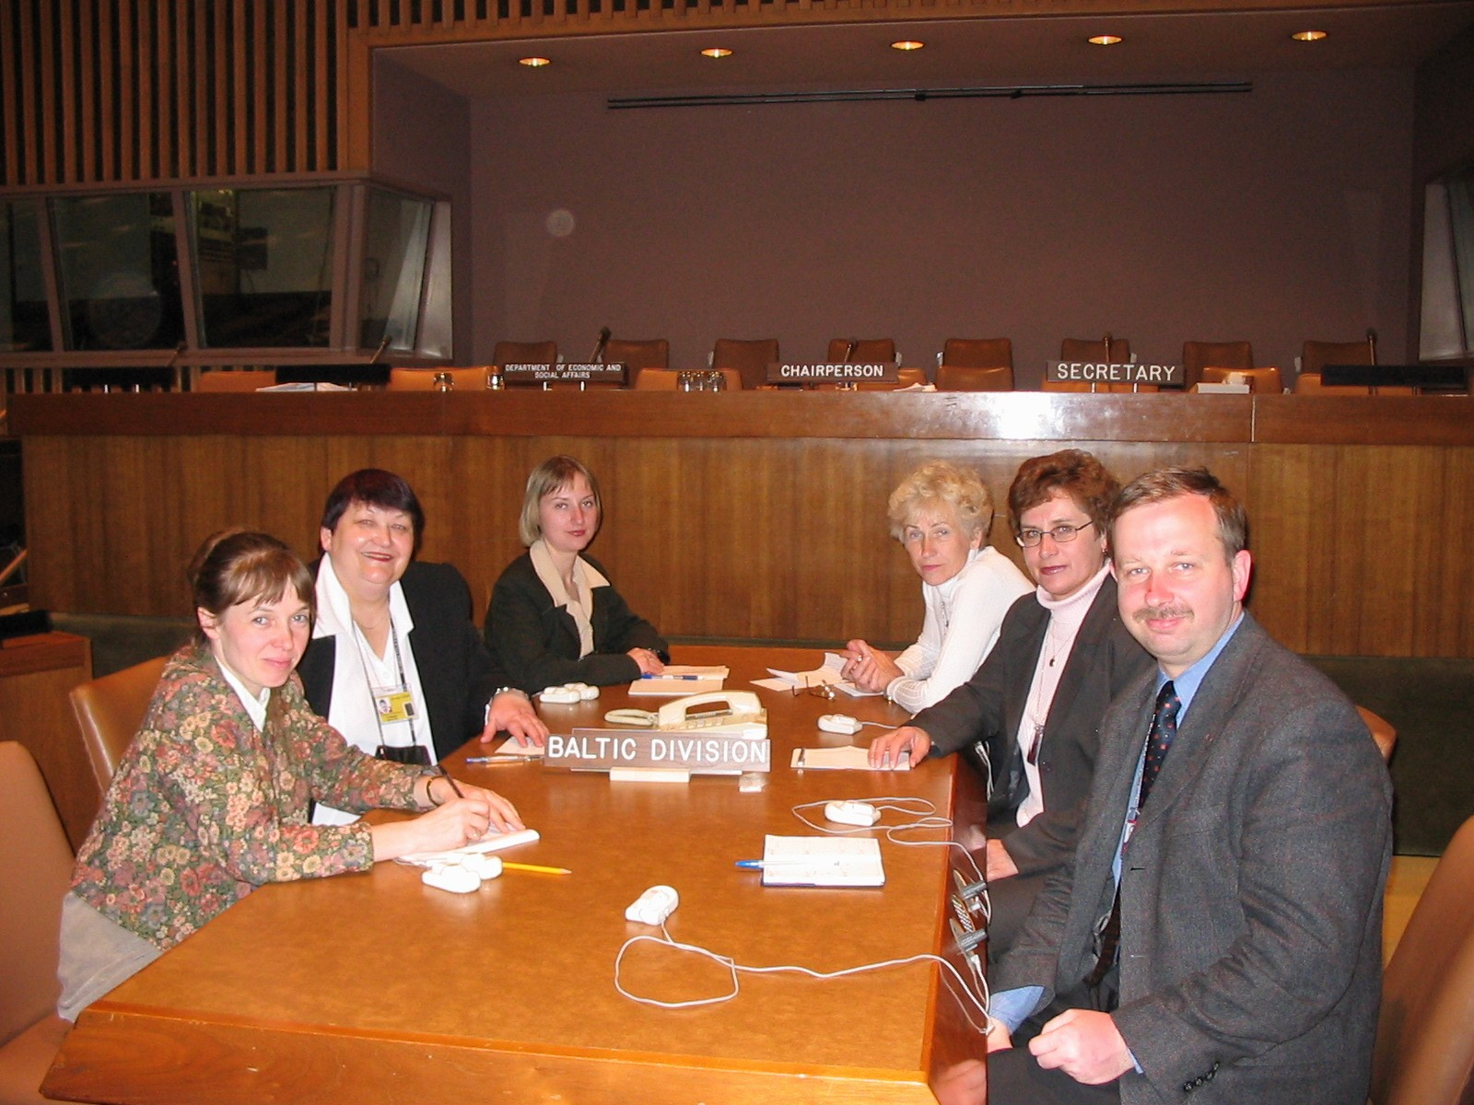

New York, UN conference room, 2004-04-20 . 22th Session of Standartization of geographical Names.
Participants of Baltic Division of UNGEGN :

Ms. Vita Strautniece, Ms. Ieva Kage (Latvia, National Land Board);
Ms. Danute Mardosiene (Lithuania , National Land Service);
Ms. Elvi Sepp (Estonia Geographical Names Board),
Ms. Male Hunt (Estonia, Maritime Administration);
Mr. Peeter Paal (Estonian Language Institute).

Documents on the Standardization of Geographical Names

- UN Resolutions
- UNGEGN Brochure (Arabic, Chinese, English, French, Russian, Spanish)
- UNGEGN Glossary of Terminology (in UN official languages) (pdf, 2.7 MB)

